1. **Design Specifications**

In the previous sections, we have identified our potential markets and customer needs. Our product should ideally satisfy our customer's qualitative needs. To provide structure and a set of goals towards meeting the customer needs outlined previously, we must first translate our qualitative customer needs into quantifiable design specifications that, if achieved, will satisfy our customer needs. The rest of this section will detail our specification generation process and our final design specifications.

The general procedure we use to define our specifications for each customer need is as follows. First, we identify what constraints result on each subsystem as a result of the constraint. Next, we determine metrics we can use to measure these constraints. Finally, we determine our target measurement values based on our customer needs and specifications of competitive products.

Below, we list out a table detailing our design specifications and what customer needs they satisfy.

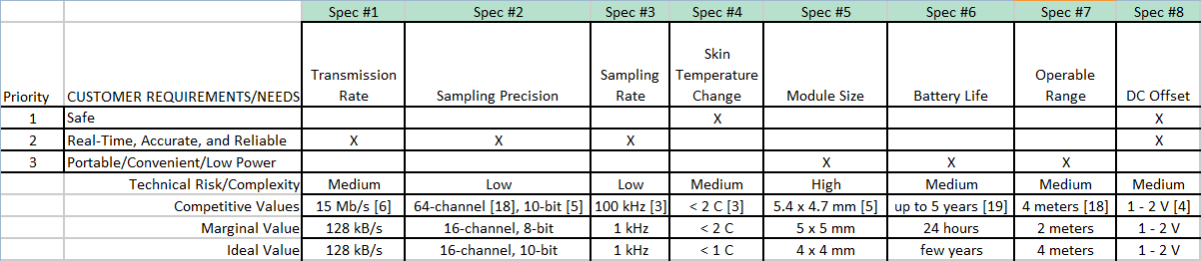

Figure 6. Design specification chart of marginal and ideal values

The first customer need listed in the table is safety. In other words, this device should not harm the user in any way to comply with FDA standards. Two issues arise because of this requirement. Since the device is battery powered and comes into direct contact with the skin, it could heat up the skin. Skin cells die after even a few degrees of temperature change, so FDA guidelines limit the maximum temperature change to two degrees Celsius[3]. The second issue that arises is that when the electrode comes into contact with the brain, an electric potential difference is formed. This potential difference, or DC offset, can be as large as two volts and can cause excess charge to leak into the brain, possibly causing adverse effects[4]. As such, our system must be able to reject up to two volts of DC offset.

Our second customer requirement is that the device must be able to transfer data in real-time. This constraint means we must be able to transfer data from each electrode to the server at a fast enough rate. 128 kb/s is our target transmission rate for each electrode in the system. If each sample is eight bits, then a 128 kb/s transmission rate can support up to 16,000 samples per second, which is more than enough samples for this device's application.

In addition to real-time capabilities, the device must also be able to obtain accurate and comprehensive data. For the data to be accurate, the precision with which we sample must be acceptable. Eight bits provides 256 different amplitude levels, which is enough to obtain a curve over a wide-range of possible amplitudes. However, since neurons have typical action potential spikes on the order of 102 microvolts, having at least one thousand different amplitude levels ensures that we have enough precision to accurately obtain every possible reading[4]. Additionally, for the data to be comprehensive, we must sample regularly. A 1 kHz sampling rate translates to one sample per millisecond, which suffices for our application.

Our last customer need is that the device should be convenient and portable. We identified three aspects to consider for satisfying this requirement. First, the module size should be small and fit on the electrodes we are working with, which have a base area of 4 x 4 mm2. However, our device can be slightly bigger than this area and still fit perfectly onto the electrode, which is why this size limitation is not one of our biggest concerns. The second aspect is the device's battery life. If the user has to replace the battery a few times every hour, then the process becomes very much a hassle. Having a battery life of one day is still not ideal, but it is a goal that is achievable for the scope of our project. The final aspect to consider is the range that the server can be placed from the electrodes and still receive accurate data. The server module will likely be on the user's body. As such, the range at which transmission between the electrode module and server can still occur needs to be about as tall as a person.

If we achieve the specifications listed above, we can deliver a competitive neural recording module with wireless capabilities to the market and facilitate the treatment and research of brain ailments.